Xbiom™ for Molecular Biomarker Research in Precision Medicine
September 9, 2016
PointCross Life Sciences Inc., Foster City, CA

There is a perfect storm brewing where advances in genomic screening, identifying molecular biomarkers and precisely targeted medicines and diagnostics, smart monitoring of patient vitals and physiology using devices such as smart phones and apps for clinical trials come together to change the landscape of the Pharmaceutical industry and healthcare itself. The increase in the number of biotech startups, the increase in approved biologics are all testament to this important trend in healthcare.

Assays on bio-samples are easily outsourced and the resulting NGS/WGS sequencing data can be further analyzed to derive the genomic mutations and their classifications. However the processes of generating sensitive results from data analysis, correlating with clinical findings and biomarker characterization and how that relates to treatment progress is a key intellectual property of the Bio-tech and Pharma company and that is better done in-house. This kind of analysis will require access to tools and IT solutions capable of handling both clinical trial data as well as biomarker data from the patient’s bio-samples. It will also require that such solutions provide researchers an easy way to look up data in public and subscribed registries for genes, proteins, RNA and pathways.

PointCross’ Xbiom™ solution integrates disparate salient data sets needed for a company developing a precisely targeted therapy based on genetic mutations that affect the proteins, or RNAs that may be implicated in the progress of a disease or serve as a reliable marker for diagnostics or therapy. When correlated to the actual clinical findings of highly stratified cohorts, Xbiom serves as a potent tool for developing therapeutic drugs for oncology, immunology, CNS or CV conditions.

Integrating biomarker-based development of medicines using translational analytics is not well aligned with the standard stage-gated clinical development processes. The kind of integrated clinical data analysis with genomic characterization is important for the biomarker scientists. Their research is punctuated by searches for a precise set of cohorts from an ongoing or legacy clinical trial where the selection is based on very specific medical history, disease stage, genomic profiles that show evidence of very specific molecular biomarkers – suspected or known, and the changes in traditional clinical findings. This type of analysis may need to be done iteratively.

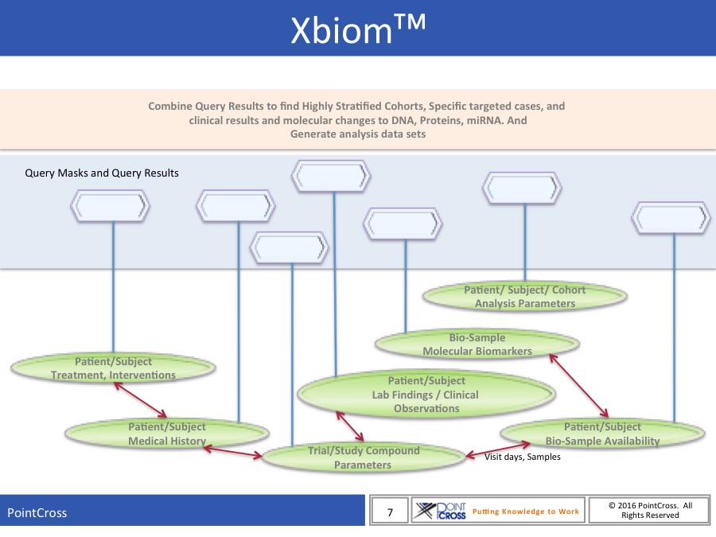

Xbiom™ is an integrated longitudinal biomarker research platform for Bio-Techs

Xbiom™ supports:

- Data analysis of clinical trial data;
- Selection of highly stratified prospective or retrospective cohorts based on:
  - Medical history,
  - Demographics,
  - Genotype,
  - Phenotype; and
  - Specific genomic markers in DNA, proteins or RNA found in the screening of the patient bio-samples.
  - Clinical findings of patients in ongoing studies
- Tracking of availability of bio-samples and associated genomic screening data

Xbiom™ provides query masks for each of these areas using Boolean logic and precise selection rules as well as allowable ranges for quantitative data with real time feedback on the number of studies and subjects that match these criteria.

Users can establish hierarchical rules from each of these query zones, as shown in the figure, to generate a precise profile of the stratified cohorts. These search criteria and the results can be stored and re-purposed by individual users or shared among collaborating scientists. Cohorts selected can be named and recorded for analysis. Clinical findings of the cohorts are available for generating the analysis data sets (ADaM).

Some Use Cases for Xbiom™

- Find a cohort of patients who have survived more than 300 days after treatment of Compound X. Patients may be selected across multiple studies. Selected patients for the cohort must be between the ages of 30 and 60, and measurements of certain blood parameters (WBC, RBC) must have been regularly measured during the monitored period. Their bio-samples are available for genomic screening and the patients shall have provided informed consent for use of their bio-samples.
- Identify subjects who have participated in clinical trials for a specific treatment, say of compound X. The subjects of interest are female and only those subjects who have Plasma samples that are valid at least until a specific data in the future, say Jun1, 2022. The care-takers or bio-banks must be shown along with the sample details and identifiers. Only those subjects who have provided samples and consent for its use will be selected.
- Find data sets among participating patients who have displayed BRCA1 and BRCA2 biomarkers and where these female patients have provided consent for genomic screening of their bio-samples. Find the methods used for the original screening and compare their results.
- On studies for compound X, find subjects that have shown concentrations of Interleukin 4 and 5 above xx pg/ml along with demonstrated mutation of YYYY molecular biomarker at position NN.

Xbiom™ - Availability
By its nature Xbiom™ infrastructure includes fairly large server systems with a big data back end and powerful software for complex search queries. It will require IT and Data Management support by the sponsors. Xbiom™ may be installed on-premise or on a hosted server farm with data storage on a software as a service basis. Support for shared access to a single instance multi-tenant facility for smaller bio-techs are available.

Support and Services

PointCross can provide turnkey support to the Bio-Techs in such areas as:

- Support for generating analysis data for both the statistical analysis planning needs as well as the needs of ad hoc biomarker researchers
- Loading and updating the bio-sample availability and inventorying the results of the screening
- Data management and preparation, or building of adaptors for automated loading of genomic screening data from labs or LIMS extracts study data from CROs. This type of curation and loading is essential for the data to be directly usable and searchable.
- Providing support to the scientists and data management on the use of the tools and discovery engines used to drive the cohort selection as well as provide additional analytics capabilities based on feedback

Contact PointCross Life Sciences for more information or a demonstration of Xbiom™ at xbiom@pointcross.com.

