Xbiom™ Regulatory (Clinical & Nonclinical)

Validated Solution for Clinical and Nonclinical Study Data Planning, Preparation (SDTM & SEND) and Submission Packaging (M4 & M5)

MySEND
All-purpose tool for your SEND needs
MySEND is a FREE, downloadable desktop toolset for all nonclinical SEND packaging, quality checks, validation, or visualization of SEND data  MySEND includes a TS.XPT generator for legacy studies, SEND Validator and SEND data Visualizer.  Soon to be released are tools for consistency and quality checking of SEND datasets against the Study Report; and tools for SEND data preparation.  PointCross Life Sciences offers optional cloud and data support services to MySEND users. For example, users may buy Study Reference Files – a digital, columnar representation of the Study Report for use with the automated comparator to check for consistency between | 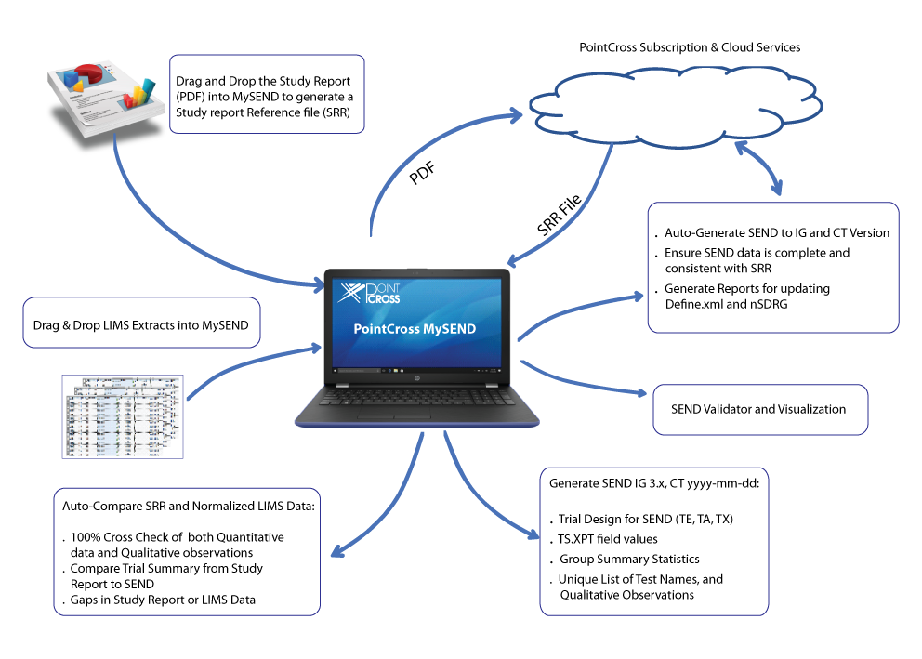
the SEND dataset and the Study Report . Cloud based services provide terminology normalization and recommendation engines using machine learning algorithms to map LIMS, Toxicologist preferred terms to SEND CT terminology, and suggested splits for original observations in Clinical Observations, Organ Macroscopy, and Histopathology into base findings and modifiers.

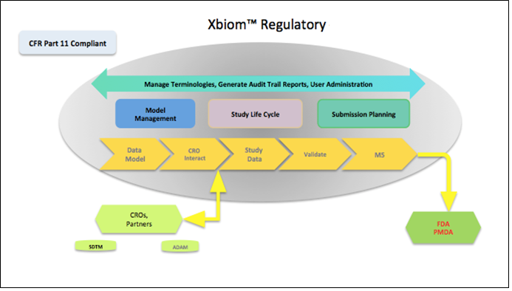 | Xbiom 3.0 is a validated solution that combines clinical or nonclinical study and submission workflows for Sponsors and CROs. Xbiom supports every stage of the SDTM or SEND data preparation process from initial study design to final review and validation checks.  Xbiom streamlines interactions between sponsors, CROs and site investigators or CRO Laboratories by establishing expected data models through specifications and automated validation of received data to these models.

get_started@pointcross.com
www.pointcross.com
+1 (866) 468-1900
Copyright © 2016, PointCross and/or its affiliates. All rights reserved.PointCross and XbiomTM are registered trademarks of PointCross Life Sciences and/or its affiliates. Other names may be trademarks of their respective owners

